STRESS
- Stress is defined as the measure of restoring force developed in a body per unit area.
- The following formula gives stress:

$\begin{aligned}σ=\frac{F}{A}\end{aligned}$
- where σ is the stress applied, F is the force applied and A is the force application area.
- The unit of stress is N/m².

Types of Stress
- Tensile Stress
The external force per unit area of the material resulting in the stretch of the material is known as tensile stress.
- Compressive Stress
Compressive stress is the force responsible for the material's deformation, such that the volume of the material reduces.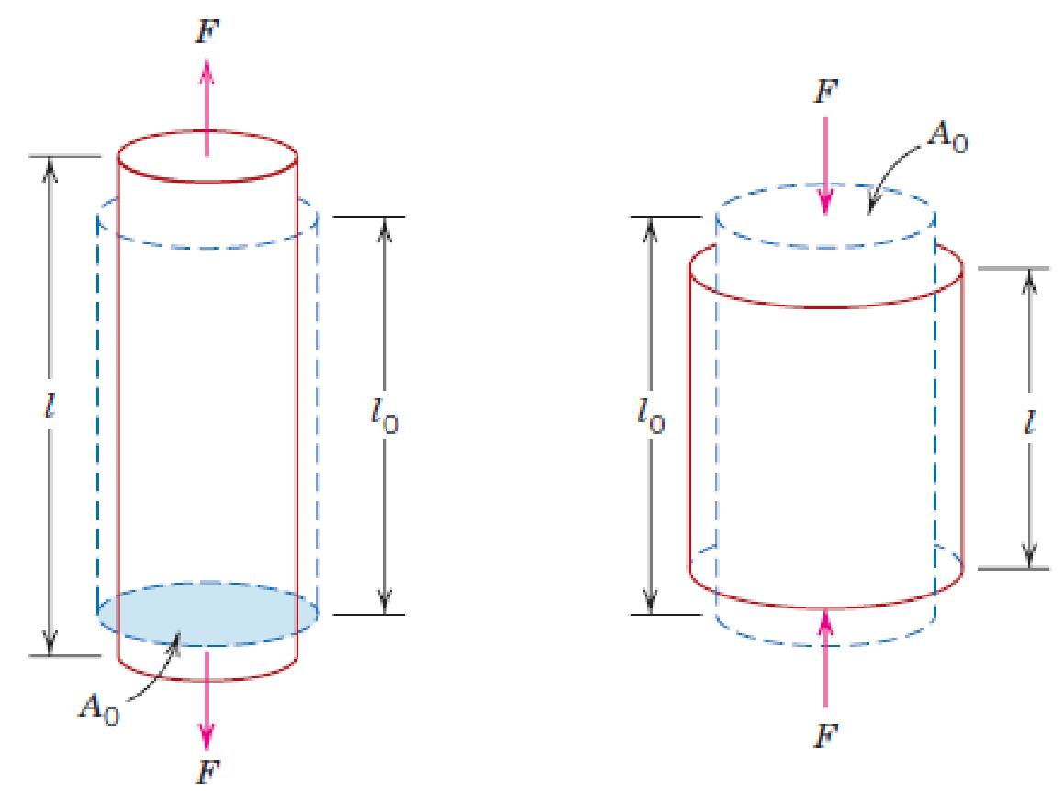

- Tensile normal stress Compressive normal stress

Difference between Tensile Stress and Compressive Stress

Tensile stress | Compressive stress
Tensile stress results in the elongation of the material | Compressive stress results in the shortening of the material
Tensile stress is due to the application of an external stretching force | Compressive stress is due to the application of external compressive force
STRAIN

- Strain is the amount of deformation experienced by the body in the direction of force applied, divided by the initial dimensions of the body.
- The following formula gives strain:

$$\begin{aligned}ϵ=\frac{δl}{L}\end{aligned}$$

Where ε is the strain due to the stress applied, δl is the change in length and L is the original length of the material.
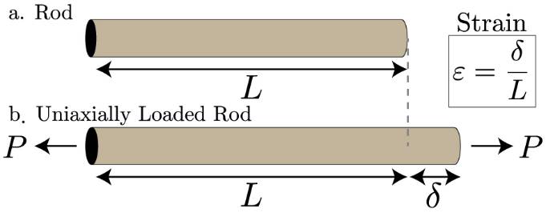
Stress-Strain Curve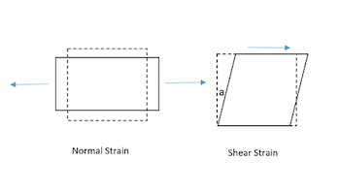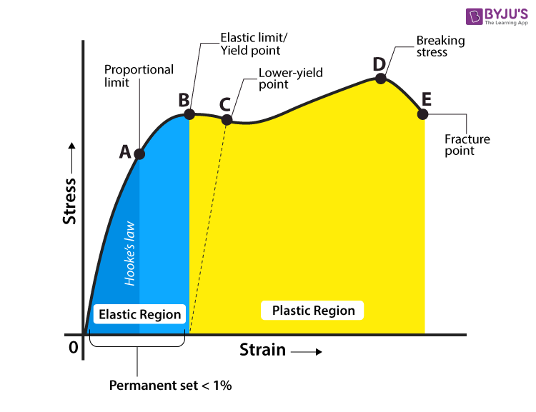

HOOKE’S LAW: Most metals exhibit a linear relationship between stress and strain up to a certain limit of stress. This is known as Hooke’s law.

$$σ=Eϵ$$

$$τ=Gγ$$

Explaining Stress-Strain Graph
The different regions in the stress-strain diagram are:

(i) Proportional Limit
It is the region in the stress-strain curve that obeys Hooke’s Law. In this limit, the stress-strain ratio gives us a proportionality constant known as Young’s modulus. The point OA in the graph represents the proportional limit.

(ii) Elastic Limit
It is the point in the graph up to which the material returns to its original position when the load acting on it is completely removed. Beyond this limit, the material doesn’t return to its original position, and a plastic deformation starts to appear in it.

(iii) Yield Point
The yield point is defined as the point at which the material starts to deform plastically. After the yield point is passed, permanent plastic deformation occurs. There are two yield points (i) upper yield point and (ii) lower yield point.

(iv) Ultimate Stress Point
It is a point that represents the maximum stress that a material can endure before failure. Beyond this point, failure occurs.

(v) Fracture or Breaking Point
It is the point in the stress-strain curve at which the failure of the material takes place.
- why are they using stress and strain instead of force and deformation?
The stress-strain curve is an intrinsic property of the material and it will be the same for all specimen sizes. The force-displacement curve will be specimen-dependent and thus it will not be a true representation of the material property.
Deformation is a measure of how much an object is stretched, and strain is the ratio between the deformation and the original length.
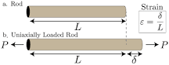

ELASTICITY
- The ability of a deformed material body to return to its original shape and size when the forces causing the deformation are removed.
- Poisson’s ratio (ν):
The ratio of lateral strain to longitudinal strain, with a negative sign as in the equation below. The negative sign is to ensure that the value of ν remains positive.

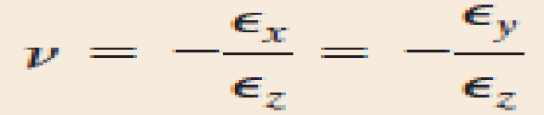
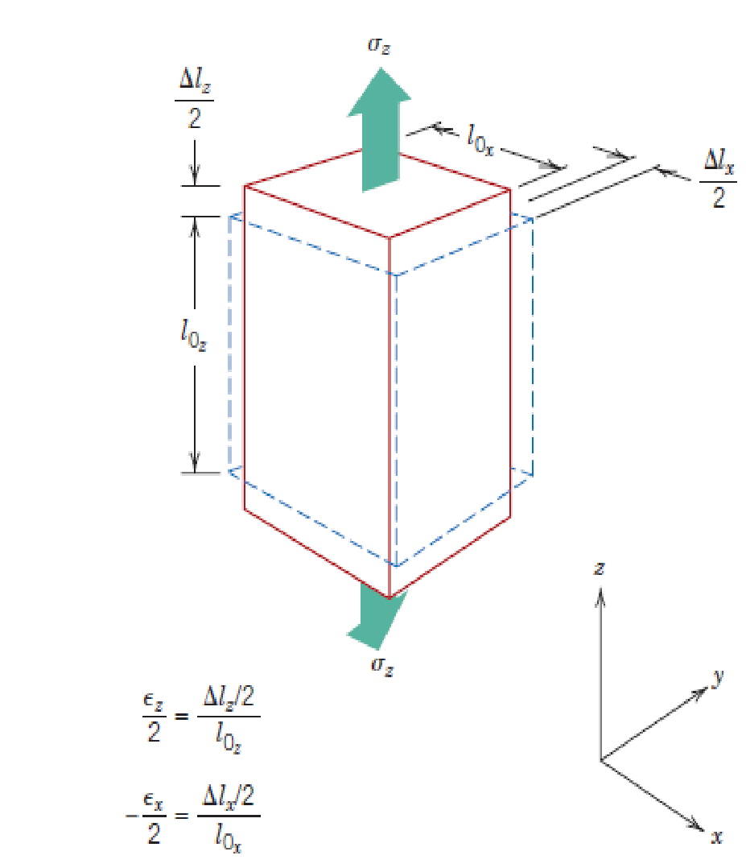

PLASTICITY
The material deforms irreversibly and does not return to its original shape and size, even when the load is removed.

- Plastic Deformation – Uniaxial Tension Test
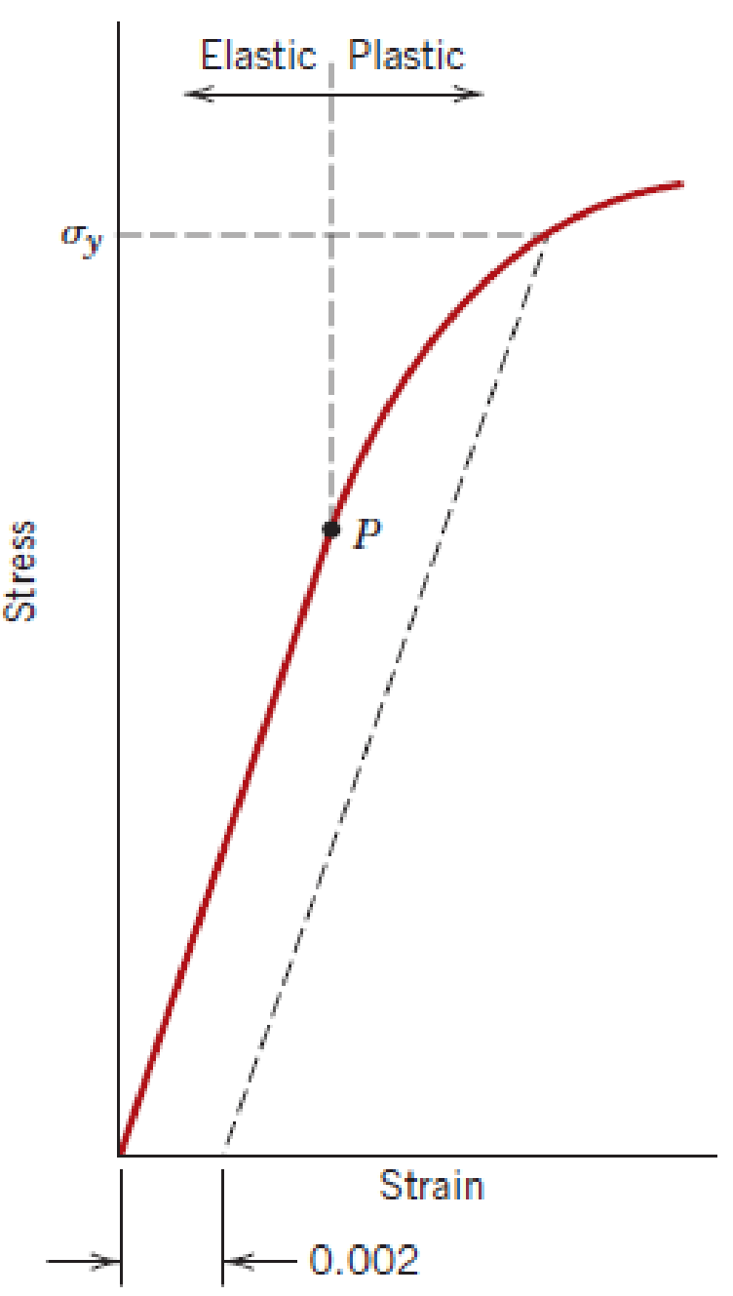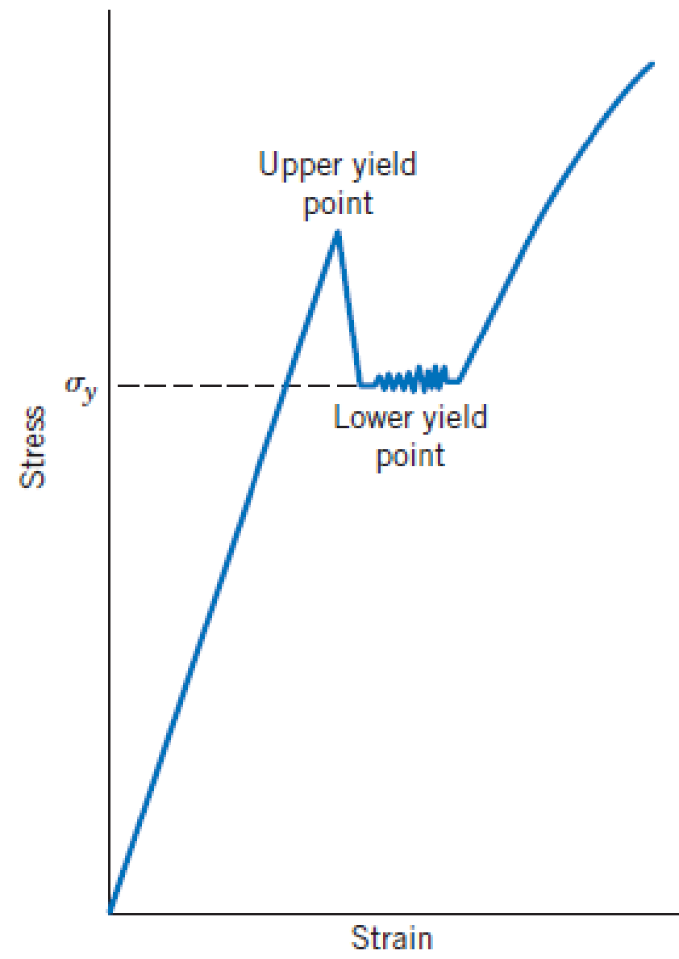
- Typical stress-strain curves for non–ferrous alloys.
- Typical stress-strain curves for ferrous alloys.

- Yielding
- Yield strength
- Large-scale atomic displacements by breaking and reforming atomic bonds

YOUNG’S MODULUS

- The mechanical property of a material to withstand the compression or elongation concerning its length. It is denoted as E or Y.[Young’s Modulus is also referred to as the Elastic Modulus or Tensile Modulus]

Young’s Modulus Formula

$$E=\frac{σ}{ϵ}$$

Young’s Modulus Formula From Other Quantities
$$E=\frac{FL_{0}}{AΔL}$$

- E is Young’s modulus in Pa
- 𝞂 is the uniaxial stress in Pa
- ε is the strain or proportional deformation
- F is the force exerted by the object under tension
- A is the actual cross-sectional area
- ΔL is the change in the length
- L₀ is the actual length

Yield Strength
- The yield strength decides whether an object is malleable. It is the point at which an object ceases to be elastic and becomes plastic.

Tensile strength
- Tensile strength is the ability of plastic material to withstand a maximum amount of tensile stress without failure. It is the point when a material goes from elastic to plastic deformation.
- Elastic deformation: The material returns to its original dimensions. Deformation is reversible and non-permanent. Valid for small strains.
- Plastic deformation: The material does not return to its original dimensions. This process is permanent and irreversible.
- Yield strength (A) - The stress a material can withstand without permanent deformation.
- Ultimate strength (B) - The maximum stress a material can withstand
- Breaking strength (C) - The stress coordinate on the stress-strain curve at the point of rupture

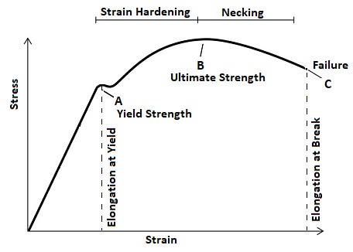
Toughness and ductility:
- Ductility is a measure of a material's ability to deform before breaking, and
- Toughness: The capacity of a material to absorb up to fracture.
- Plastic Deformation – Uniaxial Tension Test
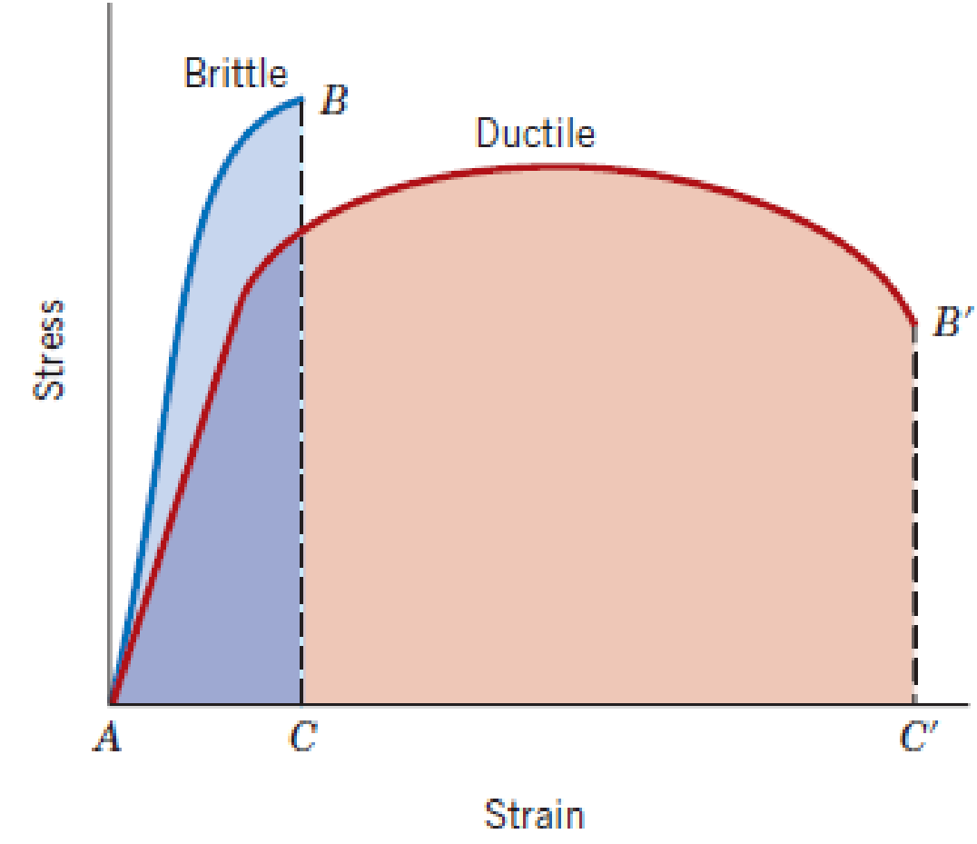
- Ductility

- Quantified as % elongation of length,

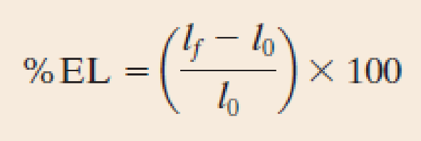

- or, % reduction in area

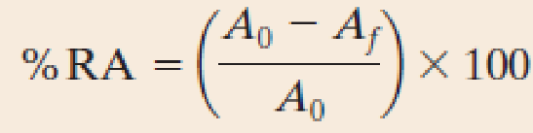
Stiffness
- Stiffness is the extent to which an object resists deformation in response to an applied force.
- Resilience: The capacity of a material to absorb when it is deformed elastically and then, upon unloading, to have this energy recovered. This property is quantified as a modulus of resilience.
$$U_{γ}=\int_{0}^{ϵy}{σⅆϵ}$$
$$Where ϵ_{y is the strain at yield point.}$$

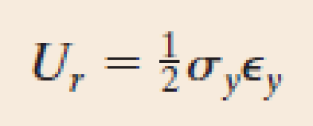

- Hardness: Hardness is the measure of a material's resistance to scratching.

